Erin Learns some JS frameworks

Import as follows:

<script src="//ajax.googleapis.com/ajax/libs/angularjs/1.3.5/angular.min.js"></script>

Module

1a. Create the app.js file use agular.module(“name”,[]);

b. Save this to a variable

Call Module. Determines the scope of this app

2a. Call this in the html page inside the body tag as follow

<body ng-app=”name”>

Controller file

3a. Create a maincontroller.js file

Add the following code

app.controller('MainController',['$scope',function($scope){

$scope.title = 'Top Sellers in Books';

}]);

Determines the scope under which this can be used

4 Under the HTML insert the following code in the main div class to open the controller

div class="main" ng-controller="MainController"

{{ expression }} is you call an expression within an html element

| can be used to filter format of display

Ng-repeat loops through an array of objects

Ng-src call an src elemenet

Ng.click is how to make a webpage dynamic.

How do you avoid code repeat when theres many elements?

Create a directive

Restrictive: indicates how it will be used ‘E’ means HTML

Scope is how this information is accessed. ‘=’ indicates a match

This is how you create something like ng-click

DYNAMIC STUFF

-Directives can be used to dynamically modify HTML

-acts as a native component of HTML rather than a layer of it.

WHAT ABOUT CONNECTING TO LIVE DATA I SHOULD KNOW THAT

-well you create something called a service to fetch JSON data

Heres an example

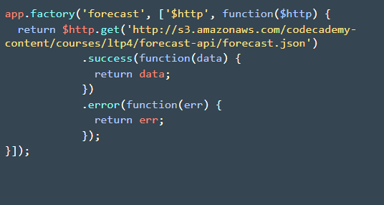

This is how to access it

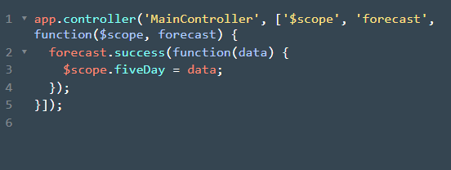

HTML displaying of data

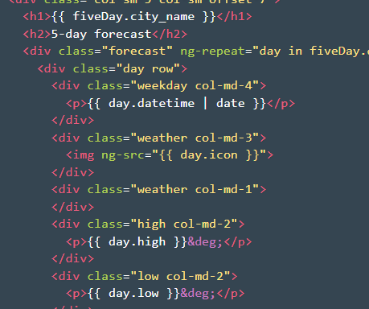

ROUTING

-now is when to actually use templates. You can direct to different templates depending the request. SUPER USEFUL